**Project Third Increment Report**

**Features developed for Increment3:**

1. Profile Page
2. History Page
3. Node modules for Forgot password, Successful Registration and Sending a mail to admin
4. Filtering Places based on user budget
5. Finding the shortest path of the places filtered on budget
6. Creation of Day to Day Plan

**Existing Services/REST API:**

<https://console.developers.google.com/google/maps-apis/>

**Detail Design of Features:**

**1. Wireframes& mockup:**

**Basic Functionality:**

Users will be able to see their profile details and also able to update their profile. Users will be able to see the history of searches by them.

Users will be able to receive email upon Successful Registration, on clicking forgot password link and also send email to admin of the application in case of any queries.

Filtering of the places can be done based on the budget given by the user. Application will fetch the details of the places which are rated high by the users in Google reviews and if they fall into the budget constraint given by the user.

There is an option for a user to create a custom plan, where user can select any place as source and destination, can look for a route in the maps and can also select multiple places and create their own.

Application creates a day to day plan considering the user budget, interest, number of days he/she planned to take the trip and also the places that are near to each other.

**2. 1 Architecture diagram:**

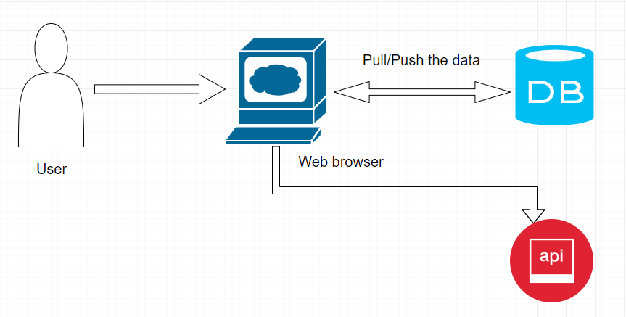

**2.2 Sequence Diagram:**

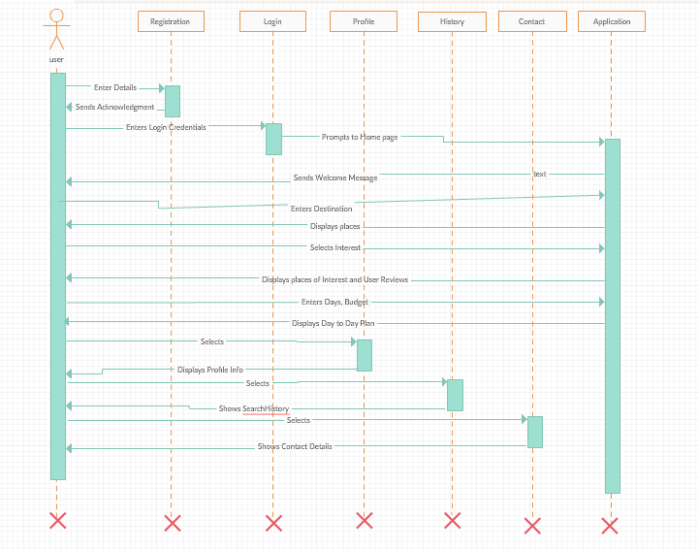

**2.3 Class Diagram:**

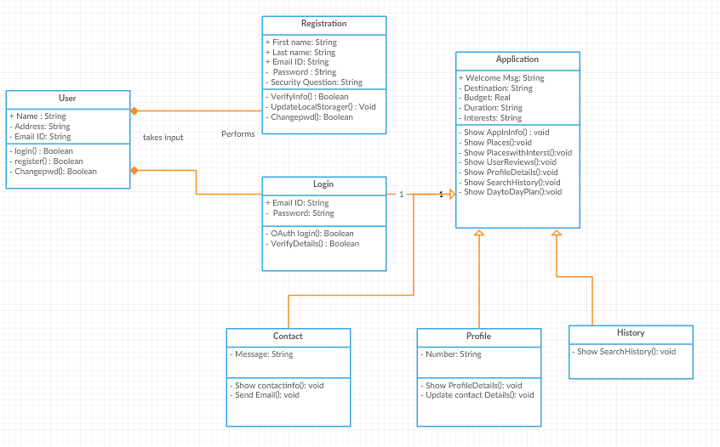

**3. User Stories**

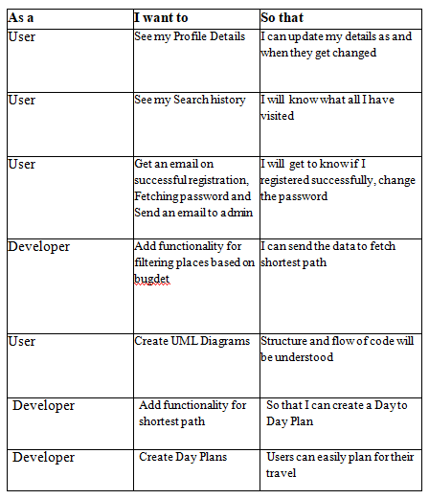

## 4. Testing

**Travel Explorer – Web Application:**

**Profile Page**

**History Page**

**Home Page**

**User Customized Plan Page**

**Day to Day Plan Page**

**Please find Github Wiki below:**

https://github.com/shannu1221/CS5551_Team8_Project/wiki/Project-Increment-1

**Project Management**

**Board Issues:**

**ZenHub report:**

**Contribution chart:**

**References:**